# Scenario #: Bug 1: Patron is incorrectly charged excessive fine when paying fines.

## Scenario Description

* Replicate Bug 1

## Version Control

|  |  |  |  |
| --- | --- | --- | --- |
| Version # | Date | Author | Description |
| 602a438065bdfe2374b1714003014e11e63eae20 | 02/10/2022 | Toby Sriratanakoul | [Initial commit](https://github.com/TitanSri/ITC205---A4/commit/602a438065bdfe2374b1714003014e11e63eae20) |
| e4cdc2c93320da320454bc2c34a720a950177bf4 | 12/10/2022 | Toby Sriratanakkoul | [Bug1 FAT Run 1 - Fail](https://github.com/TitanSri/ITC205---A4/commit/e4cdc2c93320da320454bc2c34a720a950177bf4) |
| 0efe66b415d60614b0580a4551f86c0830cb6224 | 12/10/2022 | Toby Sriratanakkoul | [Bug1 FAT Run H2 - True](https://github.com/TitanSri/ITC205---A4/commit/0efe66b415d60614b0580a4551f86c0830cb6224) |
| 5eb2b2a1fe7adedef46def39948fb18a31d5b6bc | 12/10/2022 | Toby Sriratanakkoul | [Bug1 FAT Run H3 - True](https://github.com/TitanSri/ITC205---A4/commit/5eb2b2a1fe7adedef46def39948fb18a31d5b6bc) |
| 4aa02ca77f1c84d9238ec076d0602d246904338e | 12/10/2022 | Toby Sriratanakkoul | [Bug1 FAT Run H4 - True](https://github.com/TitanSri/ITC205---A4/commit/4aa02ca77f1c84d9238ec076d0602d246904338e) |
| 7b0066e63d39637043d505de410159bb96e7319e | 12/10/2022 | Toby Sriratanakkoul | [Bug1 FAT Run H5 - True](https://github.com/TitanSri/ITC205---A4/commit/7b0066e63d39637043d505de410159bb96e7319e) |
| 11552b9ba8be6ed0a23459690ae2a772ddabfc14 | 12/10/2022 | Toby Sriratanakkoul | [Bug1 FAT Run H6 - True](https://github.com/TitanSri/ITC205---A4/commit/11552b9ba8be6ed0a23459690ae2a772ddabfc14) |
| 7b33834942a3d486f7d6543d7c488517fdc94b73 | 16/10/2022 | Toby Sriratanakkoul | [Bug1 FAT Run H7(try again) - True](https://github.com/TitanSri/ITC205---A4/commit/7b33834942a3d486f7d6543d7c488517fdc94b73) |
| 6bd8468dea19d460d07342ab9b1a0b8e15921144 | 16/10/2022 | Toby Sriratanakkoul | [Bug1 FAT Run H8 - True](https://github.com/TitanSri/ITC205---A4/commit/6bd8468dea19d460d07342ab9b1a0b8e15921144) |

## Test Scripts

The following scripts will cover this scenario:

* 1.1 Replicate Bug 1

## Use Case

* Return Book – When a book is returned two days late on fine is imposed

## Test Components/Requirements

This test scenario covers the following high-level test requirements (see scripts below for specific requirements covered by each test script):

* Need a patron with current loan
* Need a book associated with the loan
* Increment the data to two days overdue

## Script #: Replicate Bug 1

### Script Description

* Given a book overdue by two days (setup) return the book

### Testing Objective

* When a book is returned overdue by one day, then a fine of $2 should be imposed

### Setup

* Create a patron with no borrowing restrictions
* Create an available book
* Make the patron borrow the book
* Increment the data to two days past the due date

### Test Data

|  |  |
| --- | --- |
| Data | Value |
| Patron | Ln: t, Fn: j, Em: jt, PHno: 1 |
| Book Id | A: b, T: t, CNo: 1 |

### Teardown

* Reset patron to no loans, no fines
* Reset book to available
* (Remove library.obj file, and rebuild library from scratch)

### Script Steps

| **Step #** | **Test Action** | **Expected Results** | **Pass/ Fail** |
| --- | --- | --- | --- |
| 1 | Enter ‘R’ to return book | Return book, Return Item Use Case UI title and “Scan Item” prompt | P |
| 2 | Enter “1” for the books scanned | Loan listing, and “Is item damage?” prompt | P |
| 3 | Enter ‘N’ for undamaged | “Overdue fine: $2.00” message  and “Total Fines: $2.00” message  Return processing complete message  Return to main menu | P |
| 4 | Enter ‘LP’ to list patrons | Patron listed with fine owing of $2 | F |

### Test Execution

|  |  |  |  |  |
| --- | --- | --- | --- | --- |
| Date/Time | Tester | Test ID | Test Phase | Status |
| 12/10/22 | Toby Srira | Tsrira01 | System Cycle 1 | Failed |
| 16/10/22 | Toby Srira | Tsrira01 | System Cycle 1 | Passes |

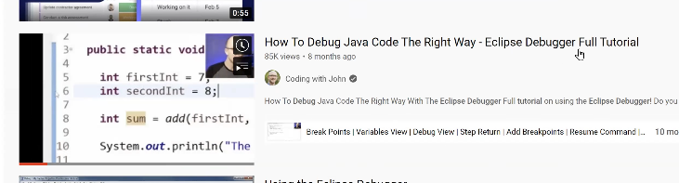

Run 1 results:

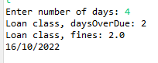

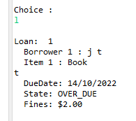

Step 1



Step 2

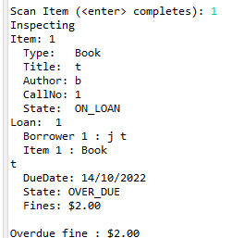

Step 3

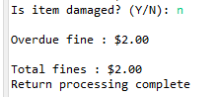

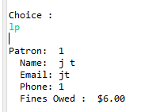

Step 4

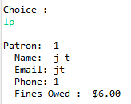

Bug1 bug log:

Commit logs can be found <https://github.com/TitanSri/ITC205---A4/commits/TobyA4>

**Simplification (observed)**

H1: Everything is all right until end if the return processing

T1: Inspect code for end of return processing.

R1: Incorrect loan value printed out before end of return processing

H1: True

Commit logs:

<https://github.com/TitanSri/ITC205---A4/commit/e4cdc2c93320da320454bc2c34a720a950177bf4>

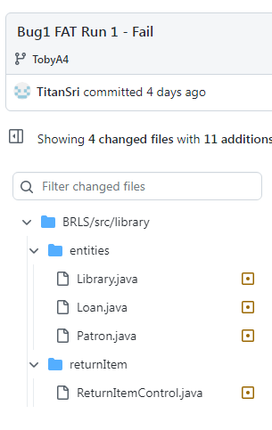

This is the first commit after testing H1, you may notice the system.out.println(); for prior testing was commented out because I forgot to run H1 with a commit.

**Tracing**

H2: Everything is all right until ReturnItemControl.dsichargeLoan>currentLoan.getPatron().incurFine(): line 91

T2: Inspect code for end of return processing.

R2: Fine Owing is $2.00

H2: True

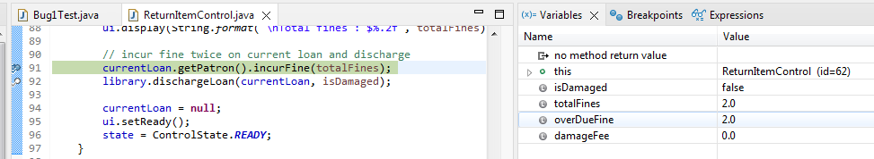

You can see in the picture, line 91 takes you to patron

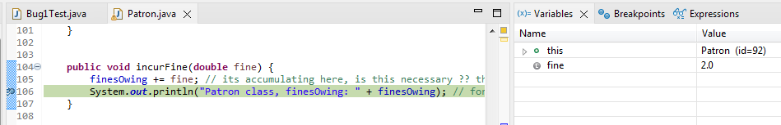



Commit logs:

<https://github.com/TitanSri/ITC205---A4/commit/0efe66b415d60614b0580a4551f86c0830cb6224>

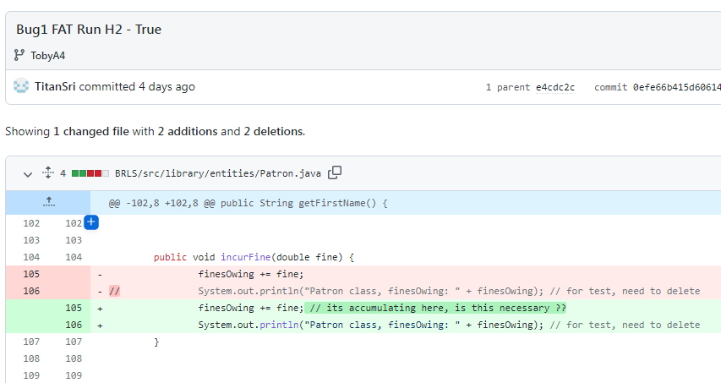

H3: Bug is after ReturnItemControl.dsichargeLoan>library.dischargeLoan() : line 92

T3: Inspect code after discharge for new value

R3: Fine owing is more than $2.00.

H3: True, its $4.00

You can see before line 92 the totalFines is 2.0

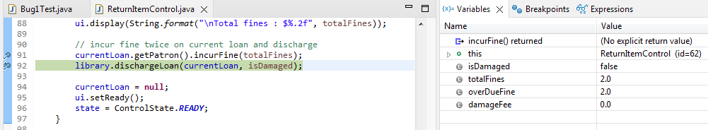

This will incur the cost again.

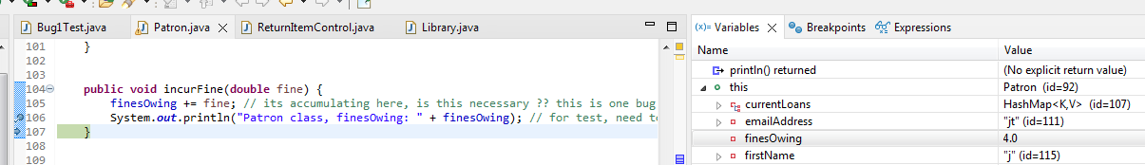



Commit Logs:

<https://github.com/TitanSri/ITC205---A4/commit/5eb2b2a1fe7adedef46def39948fb18a31d5b6bc>

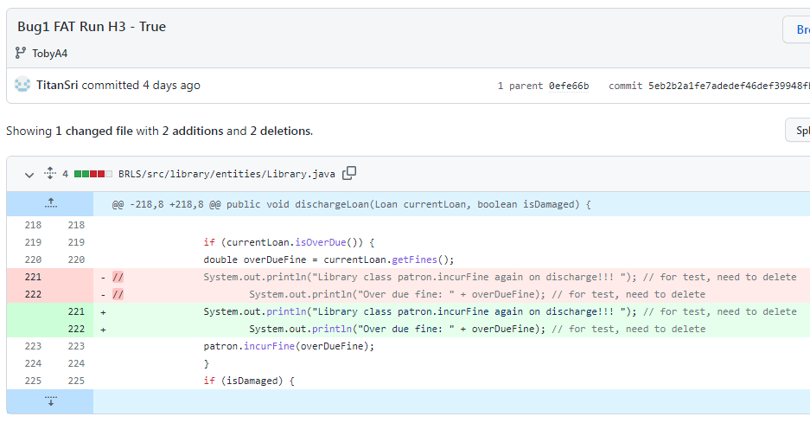

H4: Bug is in the Patron.incurFine()

T4: Inspect code for Patron.incurFine()

R4: finesOwing += fine; is adding more to the current fine: line 105

H4: True, its $4.00 (first bug found)

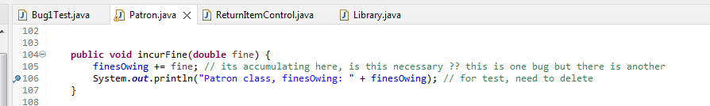

Commit logs:

<https://github.com/TitanSri/ITC205---A4/commit/5eb2b2a1fe7adedef46def39948fb18a31d5b6bc>

H5: Bug is in the Library.dischargeLoan()

T5: Inspect code for Library.dischargeLoan()

R5: currentLoan.dsicharge(): line 231, initiates Loan.discharge>patron.dischargeLoan(); line 85;

H5: True

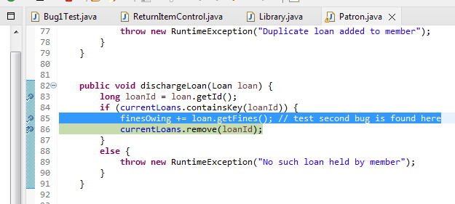

Commit logs:

<https://github.com/TitanSri/ITC205---A4/commit/7b0066e63d39637043d505de410159bb96e7319e>

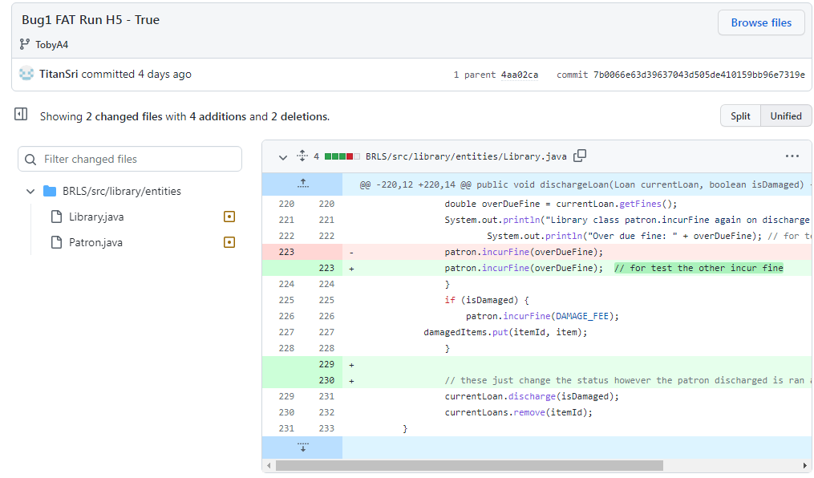

H6: Bug is in the Patron.dischargeLoan()

T6: Inspect code for Patron.dischargeLoan()

R6: finesOwing += loan.getFines(); line 85 is adding $2.00

H6: True (second bug found), fineOwing is $6.00

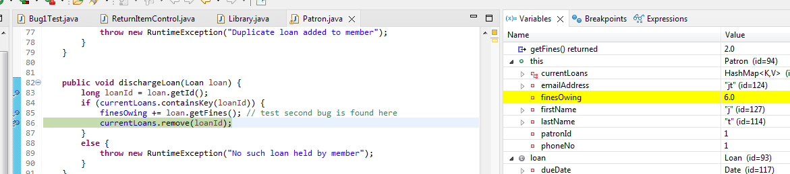



Commit logs:

<https://github.com/TitanSri/ITC205---A4/commit/11552b9ba8be6ed0a23459690ae2a772ddabfc14>

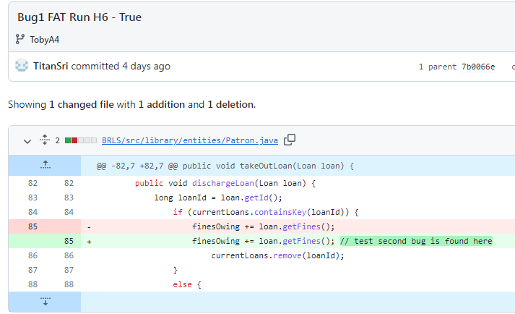

**Resolution**

H7: remove finesOwing += loan.getFines(); from Patron.dischargeLoan()

T7: Inspect code for Patron.dischargeLoan()

R7: comment out line 85; // finesOwing += loan.getFines(); // test second bug is found here- removing this line

H7: True, fineOwing is $4.00

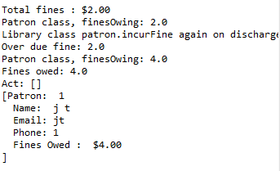

Commit logs:

<https://github.com/TitanSri/ITC205---A4/commit/7b33834942a3d486f7d6543d7c488517fdc94b73>

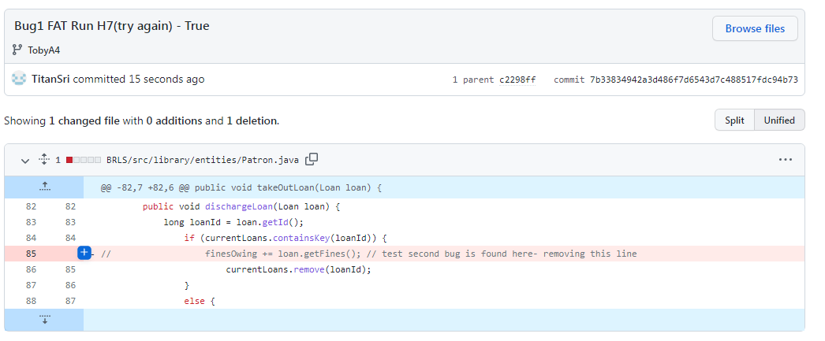

H8: H4 patron.incurFine(); is correct however the origin of the call was from Library.dischargeLoan()

T8: Inspect code for Library.dischargeLoan()

R8: Library.dischargeLoan(); line 223 contains patron.incurFine(overDueFine);

Removing line 223

H8: True

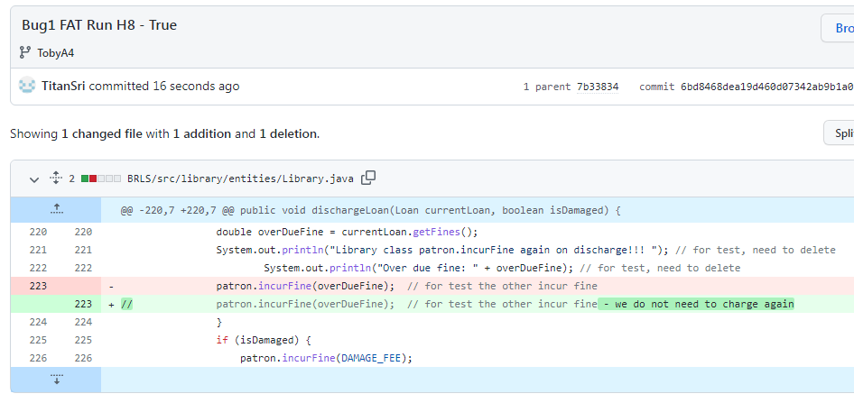

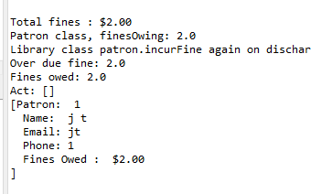

Commit logs:

<https://github.com/TitanSri/ITC205---A4/commit/6bd8468dea19d460d07342ab9b1a0b8e15921144>

